****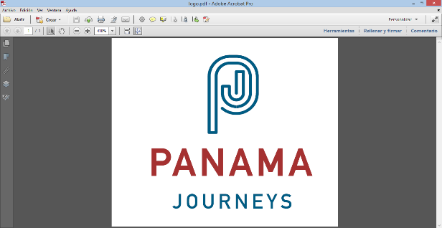

**MUD HUT BUILDING**

The mud - hut building is a Century old tradition of Panamá’s countryside. It is also a beautiful example of the local´s spirit of community as family, friends and neighbors come together in a joyful event to build a traditional Mud Hut.

I this hands-on experience, every participant plays an important role – however teamwork is key. Only by sticking to the plan, keeping the common goal in mind and ensuring an efficient communication and coordination among all workers the construction will be successful.

Using the scenery of the Panamanian tradition, the coaches provide instructions for every task and the participants rotate among the different challenges that building a mud hut features.

At the same time, the mud hut building is not just creative and fun method for team integration – the participants also leave a mark in the community by working alongside the locals and donating the mud hut an unprivileged family on Panama´s Azuero Peninsula.

**Duration:** 6 hours approximately; may vary depending the number of participants.

**Note:** It is a collective activity. A minimum of 10 participants is required.

**Recommended outfit:** comfortable old clothe to throw away, hat, sunscreen and repellent.